Kirkpatrick Fleming Primary School
Calendar for session 2015/2016
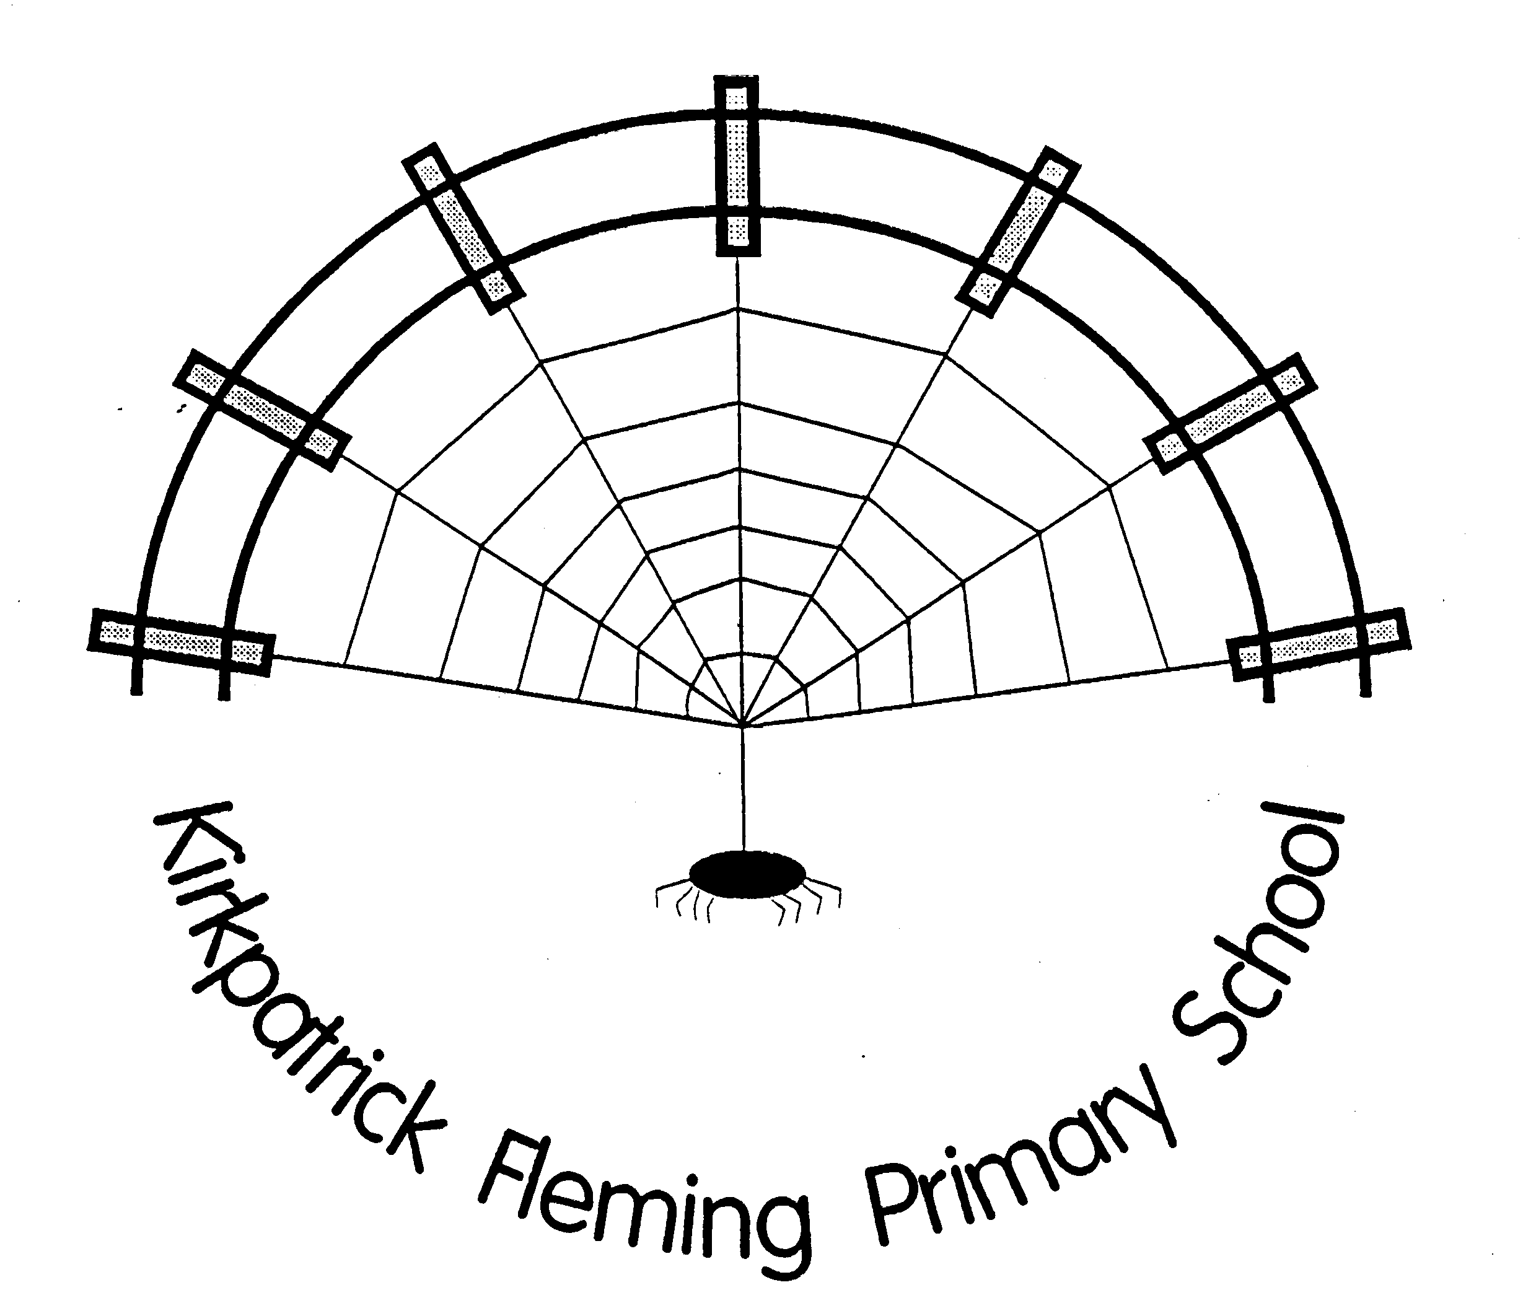

Keep Progressing Forward

Confirmed dates – many more to be added! Please keep this in a safe place.
After school groups are open to pupils at KPF and Springfield. If the group is not running in your school, pupils may be collected at 2.50 to travel to the other school. Active Schools clubs will be confirmed through the year.

Specialist teachers:
Art Mrs Veronica Carse (Tuesdays)– an old shirt to cover up uniform is required
PE Mrs Ruth Foster (Mondays T2 and T4
– tee shirt, shorts and gym shoes/trainers are required.
Strictly no football colours as per Authority guidance.
Music Ms Jillian Davis (Thursdays T1 and T3)
Support for Learning: Mrs Marjorie Pringle (Alternate Wednesdays)

TERM 1 ( 8 WEEKS.)

Week Beg: 17/08/15
Tuesday 18: Staff return
Thursday 20: Pupils return

Week Beg: 24/08/15
Monday 24: Karate P3-7 @ KPF
Monday 24: Art Attack P1-4 3-4pm @ Springfield
Tuesday 25: Lacrosse P5-7 3-4pm @ KPF
Tuesday 25: Cheerleading P4-7 3-3.45pm @Springfield- Active Schools
Thursday 27: P1 parent meeting with Mrs Matthews 12.30-1pm

Week Beg: 31/08/15
Monday 31: Karate P3-7 @ KPF
Monday 31: Art Attack P1-4 3-4pm @ Springfield
Tuesday 01: Lacrosse P5-7 3-4pm @ KPF
Tuesday 01: Cheerleading P4-7 3-3.45pm @Springfield- Active Schools
Wednesday 02: P6/7 residential Carlingwark 3pm depart
Thursday 03: P6/7 residential Carlingwark
Friday 04: P6/7 residential Carlingwark
Friday 04: P4 pupils Annan Cluster Active Games day

Week Beg: 07/09/15
Monday 07: P1 pupils begin full time
Monday 07: Karate P3-7 @ KPF
Monday 07: Art Attack P1-4 3-4pm @ Springfield
Tuesday 08: Lacrosse P5-7 3-4pm @ KPF
Tuesday 08: Cheerleading P4-7 3-3.45pm @Springfield- Active Schools

Week Beg: 14/09/15
Monday 14: Karate P3-7 @ KPF
Monday 14: Art Attack P1-4 3-4pm @ Springfield
Tuesday 15: Lacrosse P5-7 3-4pm @ KPF
Tuesday 15: Cheerleading P4-7 3-3.45pm @Springfield- Active Schools

Week Beg: 21/09/15
Monday 21: Monthly reports issued
Monday 21: Karate P3-7 @ KPF
Tuesday 22: Lacrosse P5-7 3-4pm @ KPF
Tuesday 22: Cheerleading P4-7 3-3.45pm @Springfield- Active Schools
Thursday 24: Parent Surgery 3-3.30pm
Friday 25: Macmillan Coffee Afternoon and Open Afternoon 1.30-3pm

Week Beg: 28/09/15
Monday 28: Karate P3-7 @ KPF
Thursday 01: Operation Safety trip P7

Week Beg: 05/10/15
Friday 9: School closes 3pm

TERM 2 ( 9 WEEKS.)
Week Beg: 26/10/15
Monday 26: Staff and pupils return
Monday 26: Monthly reports issued
Monday 26: Karate P3-7 @ KPF
Monday 26: Infant Reading Club 3-4pm P1-3 @ KPF
Tuesday 27: Drama club @ KPF 3-4pm P5-7
Thursday 29: Parent Surgery 3-3.30pm

Week Beg: 02/11/15
Monday 02: Karate P3-7 @ KPF
Monday 02: Infant Reading Club 3-4pm P1-3 @ KPF
Tuesday 03: Drama club @ KPF 3-4pm P5-7

Week Beg: 09/11/15
Monday 09: Karate P3-7 @ KPF
Monday 09: Infant Reading Club 3-4pm P1-3 @ KPF
Tuesday 10: Drama club @ KPF 3-4pm P5-7

Week Beg: 16/11/15
Monday 16: Karate P3-7 @ KPF
Monday 16: Infant Reading Club 3-4pm P1-3 @ KPF
Tuesday 17: Drama club @ KPF 3-4pm P5-7

Week Beg: 23/11/15
Monday 23: Monthly reports issued
Monday 23: Karate P3-7 @ KPF
Tuesday 24: Drama club @ KPF 3-4pm P5-7
Thursday 26: Parent Surgery 3-3.30pm

Week Beg: 30/11/15
Monday 30: St Andrew’s Day holiday
Tuesday 01: Drama club @ KPF 3-4pm P5-7

Week Beg: 07//12/14
Monday 07: Karate P3-7 @ KPF
Tuesday 08: Drama club @ KPF 3-4pm P5-7
Thursday 10: Christmas Concert 1.30 and 6.30pm

Week Beg: 14/12/15
Monday 14: Monthly reports issued
Monday 14: Karate P3-7 @ KPF
Monday 14: P1-4 Christmas Party
Tuesday 15: P5-7 Christmas Party
Wednesday 16: Christmas lunch tbc
Thursday 17: Parent Surgery 3-3.30pm

Week Beg: 21/12/15
Tuesday 22: Christmas Church service 2pm
Tuesday 22: School closes 3pm

TERM 3 (12 WEEKS.)

Week Beg: 04/01/16
Wednesday 6: Staff and pupils return
Week Beg: 11/01/16
Monday 11: Karate P3-7 @ KPF
Monday 11: Art Attack 3-4pm P5-7 @ Springfield
Tuesday 12: Upper reading Club P4-7 3-4pm @ KPF

Week Beg: 18/01/16
Monday 18: Karate P3-7 @ KPF
Monday 18: Art Attack 3-4pm P5-7 @ Springfield
Tuesday 19: Upper reading Club P4-7 3-4pm @ KPF

Week Beg: 25/01/15
Monday 25: Monthly reports issued
Monday 25: Karate P3-7 @ KPF
Monday 25: Art Attack 3-4pm P5-7 @ Springfield
Tuesday 26: Upper reading Club P4-7 3-4pm @ KPF
Thursday 28: Parent Surgery 3-3.30pm

Week Beg: 01/02/16
Monday 01: Karate P3-7 @ KPF
Monday 01: Art Attack 3-4pm P5-7 @ Springfield
Tuesday 02: Upper reading Club P4-7 3-4pm @ KPF

Week Beg: 08/02/16
Monday 08: Karate P3-7 @ KPF
Monday 08: Art Attack 3-4pm P5-7 @ Springfield
Tuesday 09: Upper reading Club P4-7 3-4pm @ KPF

Week Beg: 15/02/15
Monday 15: Karate P3-7 @ KPF
Wednesday 17: INSET non pupil day
Thursday 18: INSET non pupil day
Friday 19: Holiday
Week Beg: 22/02/16
Monday 22: Monthly reports issued
Monday 22: Karate P3-7 @ KPF
Tuesday 23: Body Fitness P5-7 3-4pm @ KPF
Tuesday 23: Construction Club P1-3 3-4pm @KPF
Thursday 25: Running Club P4-7 3-4pm @ KPF
Thursday 25: Parent Surgery 3-3.30pm

Week Beg: 29/02/16
Monday 29: Karate P3-7 @ KPF
Tuesday 01: Body Fitness P5-7 3-4pm @ KPF
Tuesday 01: Construction Club P1-3 3-4pm @KPF
Thursday 03: Running Club P4-7 3-4pm @ KPF

Week Beg: 07/03/15
Monday 07: Karate P3-7 @ KPF
Tuesday 08: Body Fitness P5-7 3-4pm @ KPF
Tuesday 08: Construction Club P1-3 3-4pm @KPF
Thursday 10: Running Club P4-7 3-4pm @ KPF

Week Beg: 14/03/16
Monday 14: Karate P3-7 @ KPF
Tuesday 15: Body Fitness P5-7 3-4pm @ KPF
Tuesday 15: Construction Club P1-3 3-4pm @KPF
Thursday 17: Running Club P4-7 3-4pm @ KPF

Week Beg: 21/03/16
Monday 21: Monthly reports issued
Monday 21: Karate P3-7 @ KPF
Thursday 24: Easter service 2pm
Thursday 24: School closes 3pm

TERM 4 (12 WEEKS.)

Week Beg: 11/04/16
Monday 11: Staff and pupils return
Monday 11: Karate P3-7 @ KPF
Tuesday 12: Outdoor Technology Club P4-7 3-4pm @ KPF

Week Beg: 18/04/16
Monday 18: Karate P3-7 @ KPF
Tuesday 19: Outdoor Technology Club P4-7 3-4pm @ KPF
Thursday 21: Spanish P4-7 3-4pm @KPF

Week Beg: 25/04/16
Monday 25: Monthly reports issued
Monday 25: Karate P3-7 @ KPF
Tuesday 26: Outdoor Technology Club P4-7 3-4pm @ KPF
Thursday 28: Spanish P4-7 3-4pm @KPF
Thursday 28: Parent Surgery 3-3.30pm

Week Beg: 02/05/16
Monday 02: May Day holiday
Tuesday 03: Outdoor Technology Club P4-7 3-4pm @ KPF
Thursday 05: Spanish P4-7 3-4pm @KPF

Week Beg: 09/05/16
Monday 09: Karate P3-7 @ KPF
Tuesday 10: Outdoor Technology Club P4-7 3-4pm @ KPF
Thursday 12: Spanish P4-7 3-4pm @KPF

Week Beg: 16/05/16
Monday 16: Karate P3-7 @ KPF

Week Beg: 23/05/16
Monday 23: Monthly reports issued
Monday 23: Karate P3-7 @ KPF
Thursday 26: Parent Surgery 3-3.30pm

Week Beg: 30/05/16
Monday 30: Karate P3-7 @ KPF
Friday 03: INSET non pupil day

Week Beg: 06/06/16
Monday 06: Karate P3-7 @ KPF
Friday 10: Sports Day Option 1

Week Beg: 13/06/16
Monday 13: Karate P3-7 @ KPF
Friday 17 June: Sports Day Option 2

Week Beg: 20/06/16
Secondary Schools induction week
Monday 20: Monthly reports issued
Monday 20: Karate P3-7 @ KPF
Thursday 23: Parent Surgery 3-3.30pm

Week Beg: 27/06/16
Monday 27: Sports Day Option 3
Thursday 30: End of term service 2pm
Friday 01: School closes 3pm

Staff return Wed 17 August 2016 Pupils return Thu 18 August 2016

